**RealRTCW guide for modders and mappers**

**Last edited 18/06/2022**

**New weapons script files references (“name – altname”):**

**weapon_dagger – dagger** (vampiric knife)

**weapon_delisle – delisle** (delisle carbine) – *shares ammo with thompson,colt.*

**weapon_delislescope** **– delislescope** (scoped delisle) – *shares ammo with thompson,colt.*

**weapon_mp34 – mp34** – *shares ammo with mp40*

**weapon_tt33 – tt33**

**weapon_p38 – p38** – *shares ammo with mp40*

**weapon_ppsh – ppsh**

**weapon_mosin – mosin**

**weapon_g43 – g43** – shares ammo with mauser,fg42

**weapon_m1garand – m1garand**

**weapon_m7 – m7** (rifle grenade for m1 garand)

**weapon_bar – bar**

**weapon_mp44 – mp44**

**weapon_mg42m – mg42m** – *shares ammo with venom*

**weapon_browning** – browning

**weapon_m97 – m97** (Ithaca shotgun)

**weapon_m30 – m30**

**weapon_welrod – welrod** – *shares ammo with snooper*

**weapon_holycross** **– holy cross**

**weapon_revolver** **– revolver**

**weapon_grenadesmoke – smokeGrenade** (airstrike signal)

**weapon_poisongas – poison gas**

**New ammo script files references:**

**ammo_poison_gas – poison gas**

**ammo_m7 – m7_ammo**

**ammo_holyspirit – spirit –** *used by holycross*

**ammo_ttammo – ttammo** – *used by ppsh,tt33*

**ammo_ttammo_l – ttammol**

**ammo_mosina – mosina** – *used by mosin rifle*

**ammo_barammo – barammo** – *used by bar,garand*

**ammo_barammo_l – barammol**

**ammo_44ammo – 44ammo** – *used by mp44*

**ammo_44ammo_l – 44ammol**

**ammo_m97ammo – m97ammo**

**ammo_revolver – revolverammo**

**New holdables references:**

**holdable_adrenaline**

**holdable_bandages**

**Re-enabled Q3 powerups references:**

**item_quad** – quad damage

**item_haste** – speed powerup

**item_enviro** – protective suit

**item_invis** – invisibility

**New enemies:**

**ai_dog**

**ai_priest**

**ai_xshepherd**

**Atmospheric effects:**

RealRTCW implements atmospheric effects system from Wolfenstein: Enemy Territory.   
It includes rain and snow. To add snow into your map add **“atmosphere”** key parameter to your **worldspawn** entity (click on any geo non scripted brush).

As a value for this key parameter you can use these presets:

*T=SNOW,B=5 10,C=0.5,G=0.3 2,BV=50 50,GV=30 80,W=1 2,D=15000* (strong snow - used on norway)

T=SNOW,B=5 10,C=0.5,G=0.3 2,BV=20 30,GV=25 40,W=3 5,D=5000 (weaker snow - used on escape1)

T=RAIN,B=5 10,C=0.5,G=0.5 2,BV=50 50,GV=200 200,W=1 2,D=5000 (strong rain - used on dark)

**Atmoshperic effects CVARs:**

**cg_atmoshpericeffects** - disables\enables atmospheric effects

**cg_forceatmosphericeffects** - 0- no force, 1- rain, 2- snow. This way you can force atmoshpericeffects in-game on any map. Requires vid_restart.

**cg_lowAtmosphericEffects** – 0 - high quality (dont recommend that, cause it will cause particles bugs), 1- medium quality(no raindrops), 2- disables completely

**Automatic AI attributes system:**

RealRTCW introduces an easier way to rebalance AI in the game.

In vanilla game, if you do not specify certain attribute(for example *aim_accuracy*) in the .ai file – game will take its value from the code. Those values are specified in the aidefaults functions accessible only in the code.

However RealRTCW takes it to another level in different ways.

First of all aidefaults values parsed out of the code into txt files with **.aidefaults extension.**

They located in **z_zrealrtcw_scripts.pk3/aidefaults**

All default attributes values are specified there for each AI type.

Secondly, certain values like **aimSkill, aimAccuracy, attackSkill, reactionTime, aggression and startingHealth** could be randomized in certain range for each of five RealRTCW difficulty levels. It goes from easy to realism.

So basically, if you want to use this system you **DO NOT NEED** to specify needed attributes in the .ai files. **As I said – if you do not specify attribute in .ai file it will take it from .aidefaults.** This allows you to do massive balance changes without editing each .ai on every map. But it is still optional.

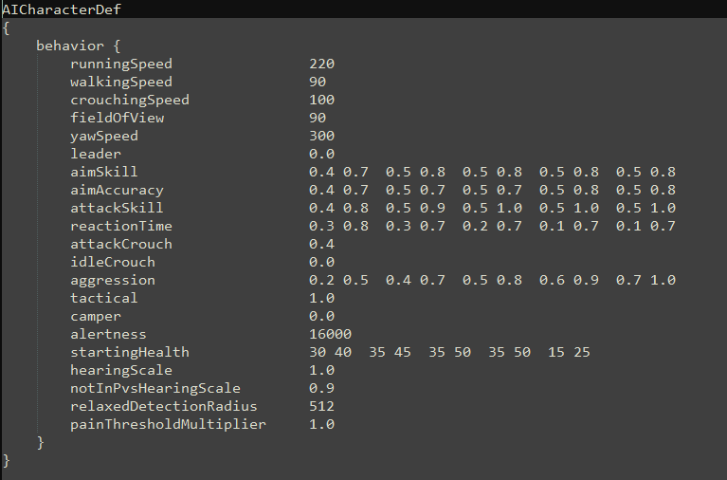

**.weap files system:**

All weapons media including sounds,icons,models,etc. is now defined in **.weap files** instead of the code. This was ported from Wolfenstein: Enemy Territory.

However, this system was greatly expanded, since all weapon parameters like fire rate,damage,reloading time was parsed out of the code into .weap as well.

**All .weap files are located in z_zrealrtcw_scripts.pk3/weapons/**

It’s structure should be self-explanatory. Take a look at the BAR ammo section: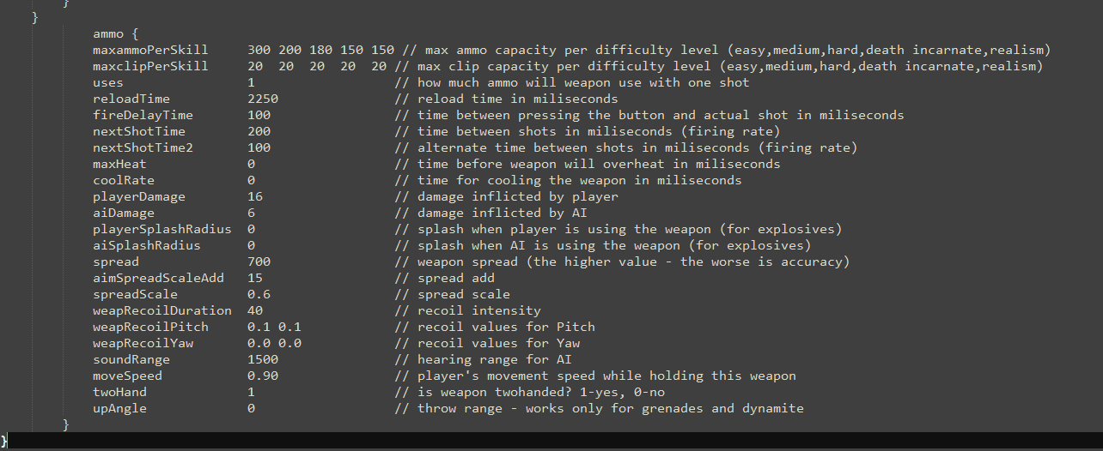

**.ents files system**

This was ported from RTCWCoop and allows you to add more entities onto your maps without recompiling them (very useful for vanilla maps). You add entities into .ents the same way Radiant adds them onto your map – simply define its **classname** and **origin**. Classnames could be looked up in Radiant. For RealRTCW specific classnames take a look at the list I specified in the beginning.

As for the origin, you can simply launch the map in the game, stand on the point you want to add your entity and type in the console **“/where”.** This will give you the exact coordinates of the spot.

Additional AIs must be specified in .ai file as well. Just like you normally do while creating the map.

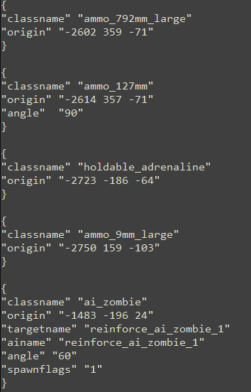

**Subtitles**

Specific CVAR: cg_drawsubtitles – enables/disables subtitles

Located in **z_realrtcw_text.pk3/text/EnglishUSA/maps**

Each map has its specific file for subtitles.

Basically you reference script name of the audio file, where AI speaks, and after that specify the text.

Be aware of the **50 symbols limit** in the single string. Going over it will lead to visual subtitles glitches. Just go to the next string like that:



I strongly suggest you to take a look at RealRTCW subtitles files and do your subtitles accordingly to its structure.

**Expanded scripting**

You can now reference CVARs in the .ai and .script files. For example you can specify spawn of the certain enemis depending on the CVAR value:

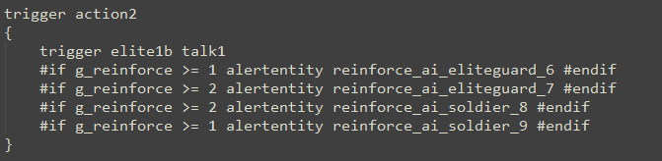

Or you can give AI certain weapon:

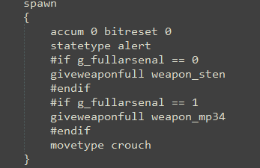

**New script functions:**

**giveweaponfull** – basically do multiple things in one go. Takes away all AIs weapon, gives him specified weapon, fills both reserve ammo and current clip to the max and selects the weapon itself.

**drop_weapon** – makes AI to toss his current weapon.

**changeaiteam** – change team of the AI on the fly.

**changeainame** – changes AI script name on the fly.

**burn** – make em burn.

**giveammo –** gives player an actual ammo item

**givehealth** – gives player an actual health item

**givearmor** – gives player an actual armor item

**giveinventory** – gives holdable item

**Difficulty specified .ai and .ents files**

You can use specific .ai and .ents files for your maps. For this you need to create additional folders for each difficulty **inside maps folder** in .pk3. You should name those folders like that: **easy, medium, hard, max, realism.**

Now throw your .ai and .ents in those folders and game will use separate file for each difficulty level.

**New CVARs:**

* g_jumptime - enable/disable strafejumping
* cg_drawsubtitles - enable/disable subtitles
* cg_solidcrosshair - enable/disable solid crosshair (ported from RTCWCoop)
* cg_bloodblend - enable/disable blood on HUD (ported from RTCWCoop)
* cg_bobbing - enable/disable bobbing while crouching (ported from ETLegacy)
* cg_sniperscrosshair - enable/disable crosshairs for unscoped sniper rifles
* cg_atmosphericEffects - enable/disable atmospheric effects
* cg_lowAtmosphericEffects - enable/disable low quality atmospheric effects
* cg_forceAtmosphericEffects - force specific type of atmospheric effects
* cg_autoReload - enable/disable autoreload (ported from ET)
* g_bodysink - enable/disable bodysink
* g_gunposlock - varied view weapon positions
* g_airespawn - enable/disable AI respawn (ported from RTCWCoop)
* g_reinforce - enable/disable AI reinforce (ported from RTCWCoop)
* g_fullarsenal - affects set of weapons player will recieve during campaign
* g_fireonthemove - allows AI to shoot rifles on the move
* g_weaponfalloff - enables damage falloff for SMGs and pistols
* g_aicanheadshot - allows AI to do headshots
* g_spawnpriests – enable/disable Priest AI spawn
* g_spawndogs – enable/disable Dog AI spawn
* g_spawnxshepherds – enable/disable X-Shepherd AI spawn
* cg_hudstatus – choose hud type
* cg_hudWeapIcon – enable/disable weapon icon
* cg_hudAmmoClip – enable/disable ammo icon
* cg_hudStamina – enable/disable stamina bar
* cg_journalstyle – enable/disable journal notifications